Exp No: 24
MODELING CLOCK-DRIVEN CONCURRENT PROCESSES USING SC_THREAD AND WAIT() IN SYSTEMC
PROGRAM:
#include <systemc>

using namespace sc_core; using namespace std;

SC_MODULE(ClockExample) { sc_in<bool> clk;

void process() { while (true) {
wait();
cout << "Time: " << sc_time_stamp()
<< " - Clock Triggered" << endl;
}
}

SC_CTOR(ClockExample) { SC_THREAD(process); sensitive << clk.pos();
}
};

int sc_main(int argc, char* argv[]) { sc_clock clock("clock", 1, SC_NS);

ClockExample module("module");

module.clk(clock);

sc_start(5, SC_NS);

return 0;
}
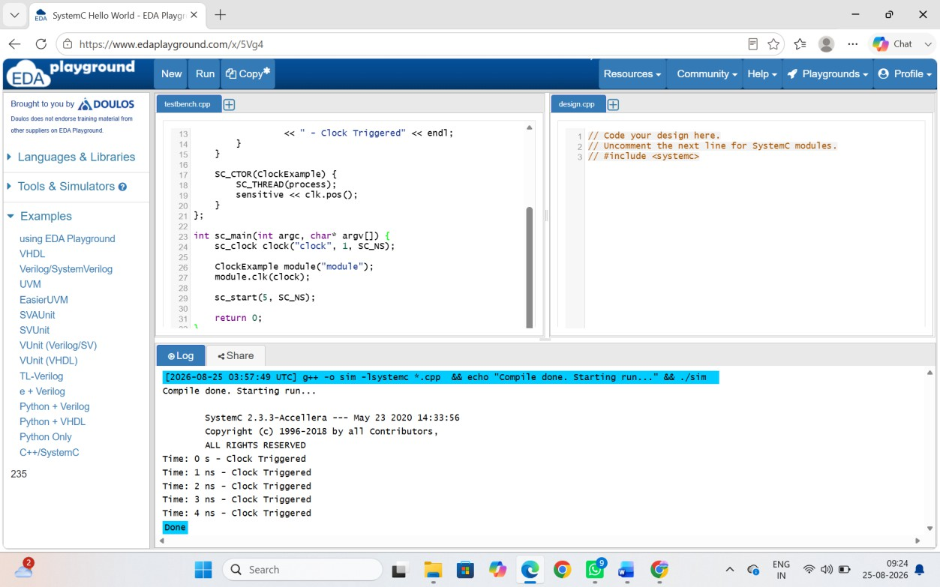
OUTPUT

